IKEA Black and White Cupboard

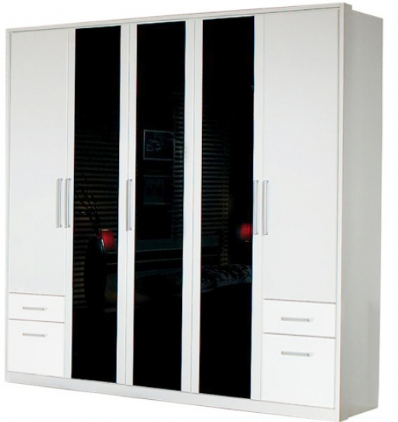

|  |
| --- |
| **DESCRIPTION** |
| IKEA dream designing has introduced an extra space wooden cupboard with two slim doors with two chests in each. The cupboard has a center three black doors which are pushed to slide up. It gives you and your house a complete different look with its obedient design increases the natural glance of the house. |

|  |  |  |
| --- | --- | --- |
| **Price** | **5000$** | |
| **Dimensions** | **H** x **W** x **L** | **75in x 27in x 54in** |
| **Features** | **There are three push to slide up doors and two handled door with four chests altogether.** | |
| **Finished** | **Scratch Free Slider** | |
| **Available in** | **Black and White Combo** | |